## **Power BI Assignment 2 - DAX, Data Visualization**

**Calculated Columns:**

**1.Created a Calculated Column for 'Category Type'**

**Category Type = CONCATENATE('Order Details'[sales]," "&'Order Details'[Sub-Category])**

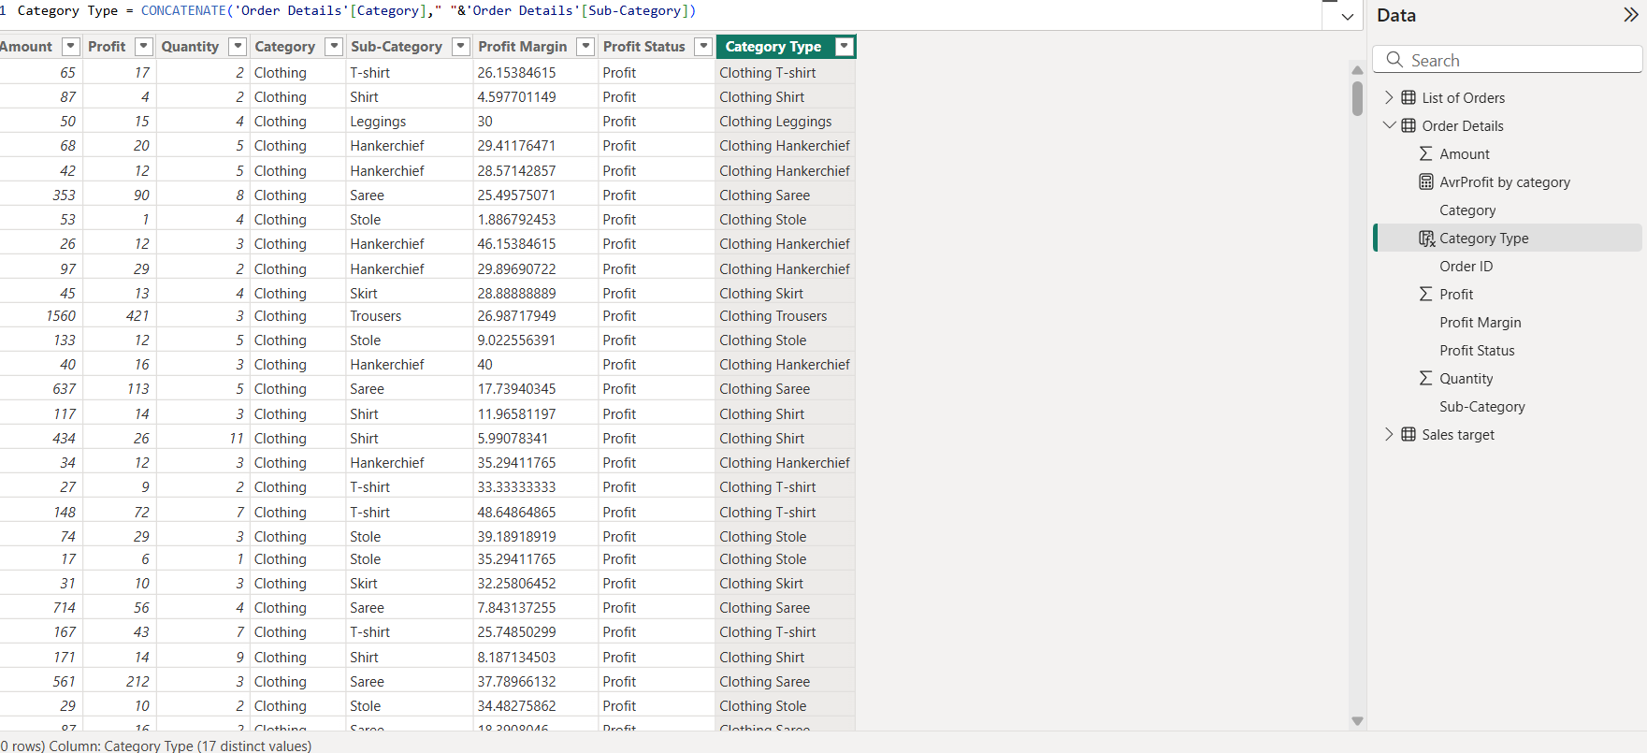

This above image shows creation of a new column “Category Type” by using a concatenate formula for “Category” and “Sub-Category” columns.

**2.Calculated Revenue per Order in Order Details Table**

**Revenue Per Order = 'Order Details'[Amount]*'Order Details'[Quantity]**

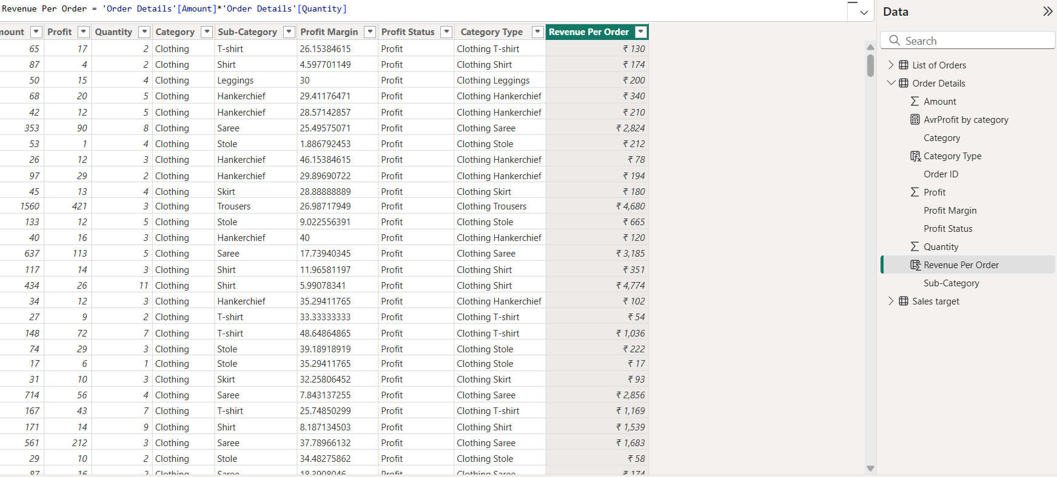

This above image shows, created a new column as “Revenue Per Order”, by using formula Revenue = Amount * Quantity.

**3.Created a Calculated Column to Categorize Sales**

**Sales Category = if('Order Details'[Amount]>Average('Order Details'[Amount]),"Above Average","Below Average")**

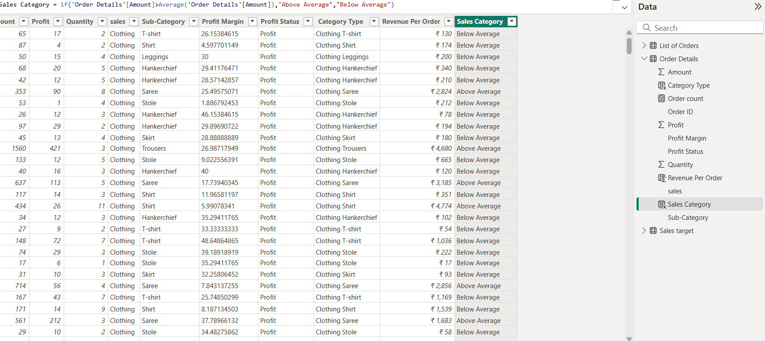

This above image shows a new column “Sales Category” created by using the “If” formula.

**Calculated Measures:**

**Calculated Order Count**

**Order count = count('Order Details'[Order ID])**

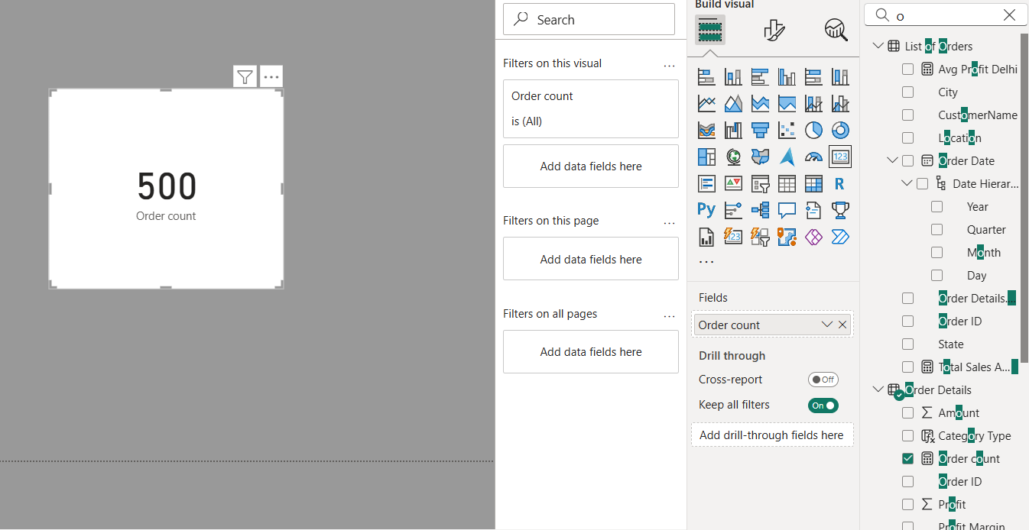

Here created a new measure to find the “Order count” of values in “Order Details”.

**Calculated Average Profit in Delhi**

**Avg Profit Delhi = CALCULATE(AVERAGE('Order Details'[Profit]),'List of Orders'[City]="Delhi")**

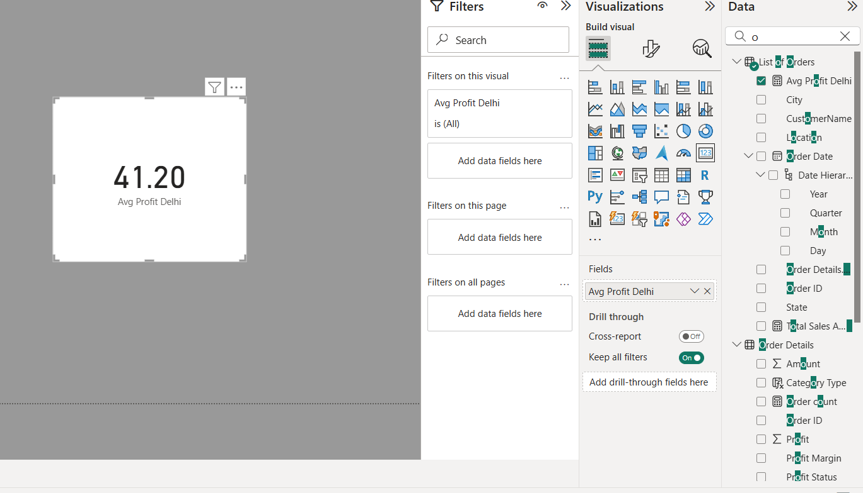

Here created a new measure to find the Average Profit for order placed in “Delhi”.

**Calculated Year-to-Date (YTD) Sales**

**Total Sales Amount(YTD) = CALCULATE(sum('Order Details'[Amount]),DATESYTD('Sales target'[Month of Order Date]))**

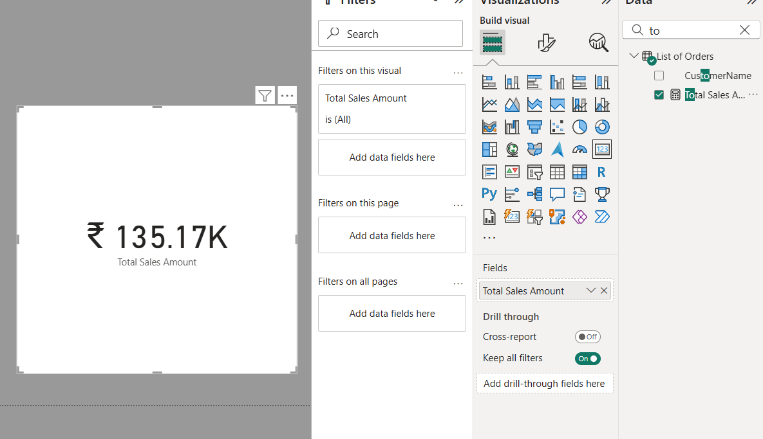

Here created a new measure to find the total sales from earliest order upto each order(YTD).

**Data Visualization:**

Sales Target Achievement by Category

**Clustered Column Chart**

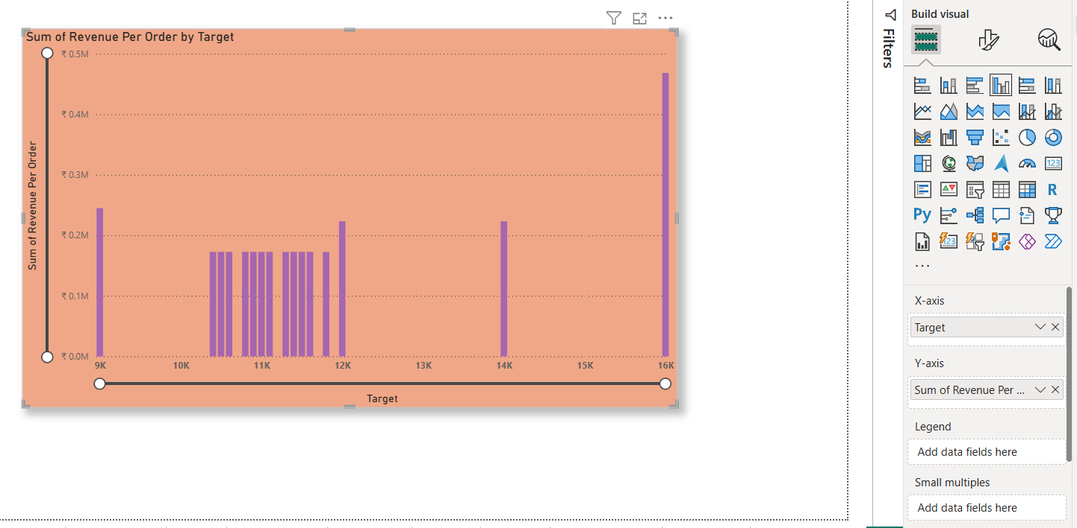

Here, X-axis Target(sale),

Y-axis Revenue per sale.

The above clustered column chart explains clearly about the actual sale with sale target by category.

Max Profit Margin by Sub-Category

**Donut Chart**

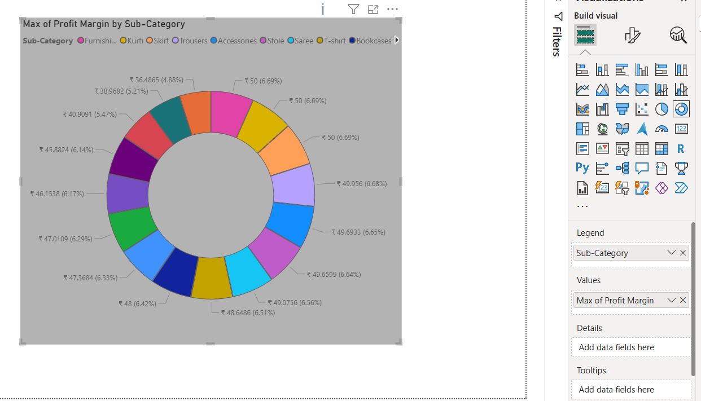

Image explains, about Maximum profit margin for each sub-category of products.

Monthly Sales Trend

**Line Chart**

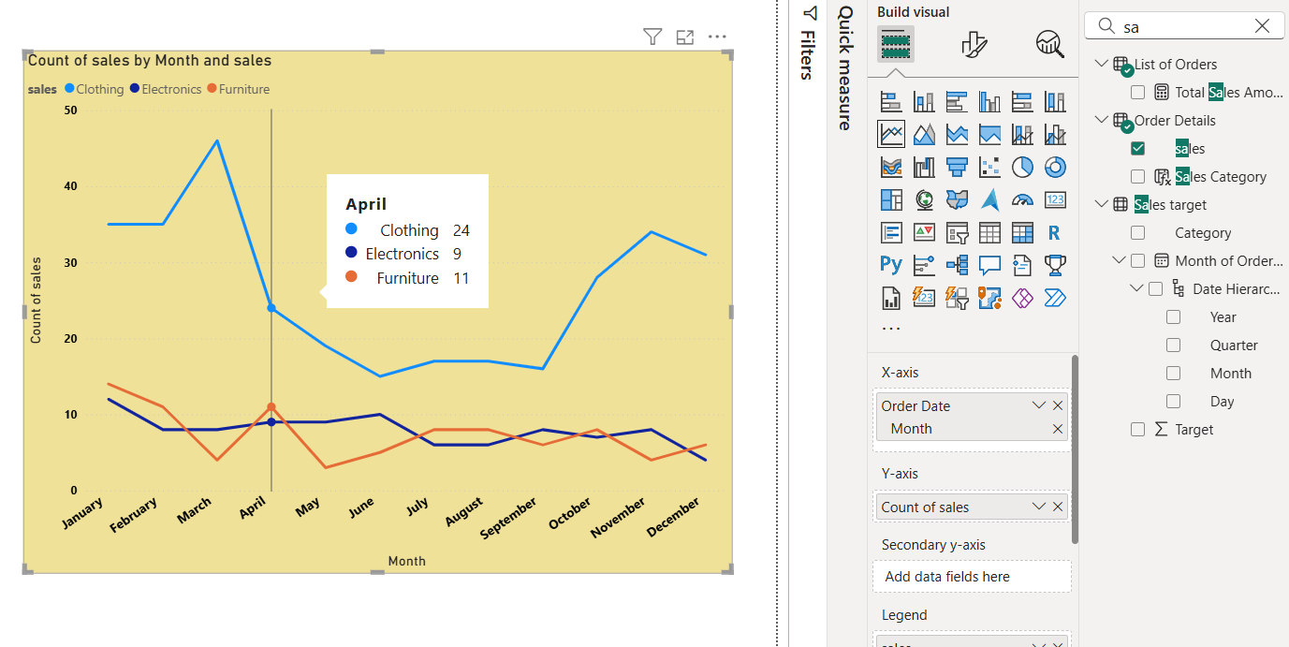

Here,

X-axis order date “monthly”

Y-axis Sales

The line chart tells the trends of monthly sales over time.

Comparison of Profit and Quantity by Sub-Category

**Scatter Chart**

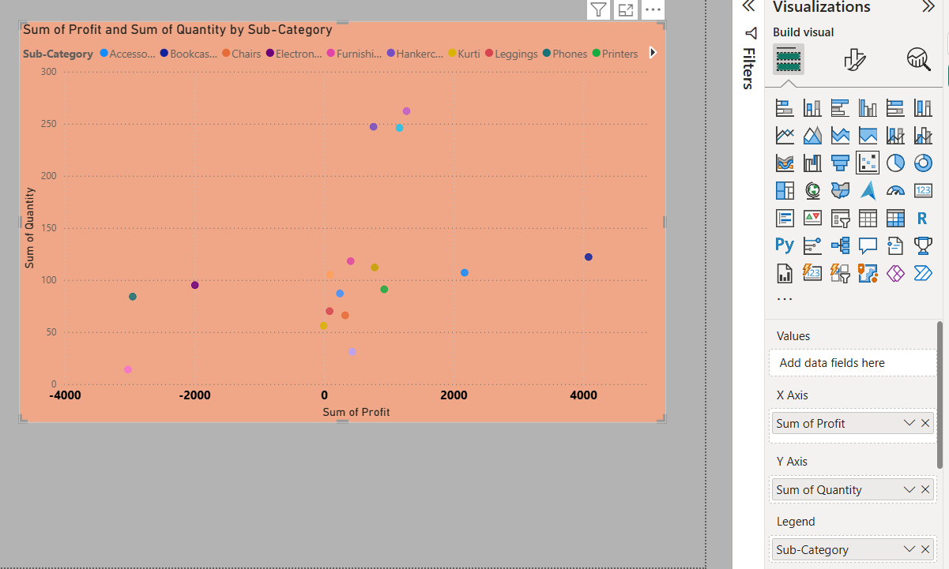

Here X-axis Profit

Y-axis quantity

Shows relationship between profit and quantity sold for different sub-categories.

Comparison of Total Sales Amount and Target

**Multi Row Card**

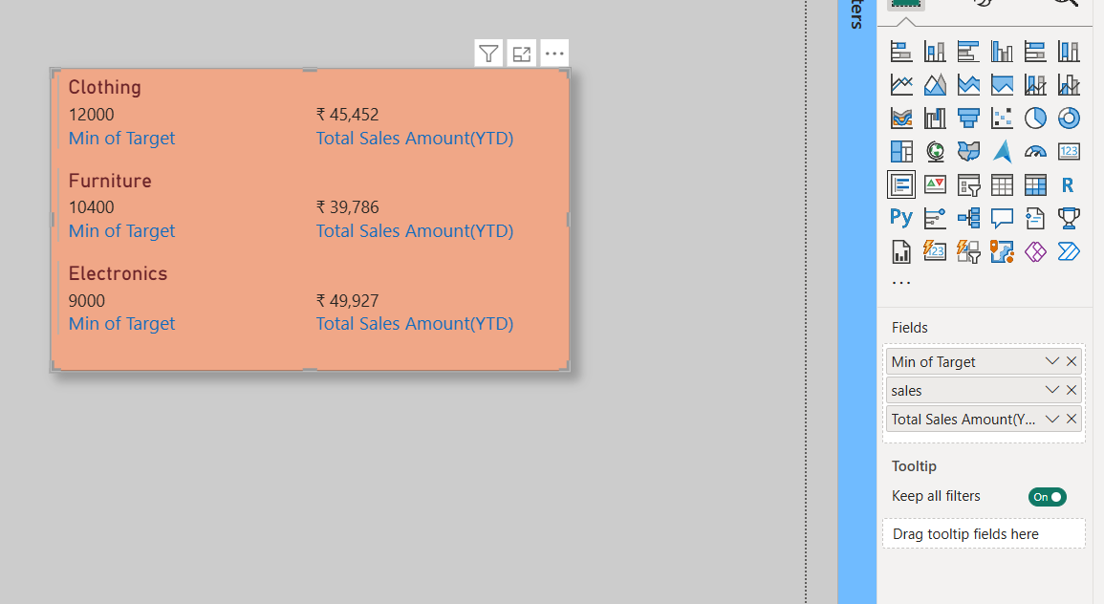

The above card explains about the total sales amount alongside the sales target, also minimum target for each segment created by using the multi row card.

Sales Performance Matrix

**Matrix View**

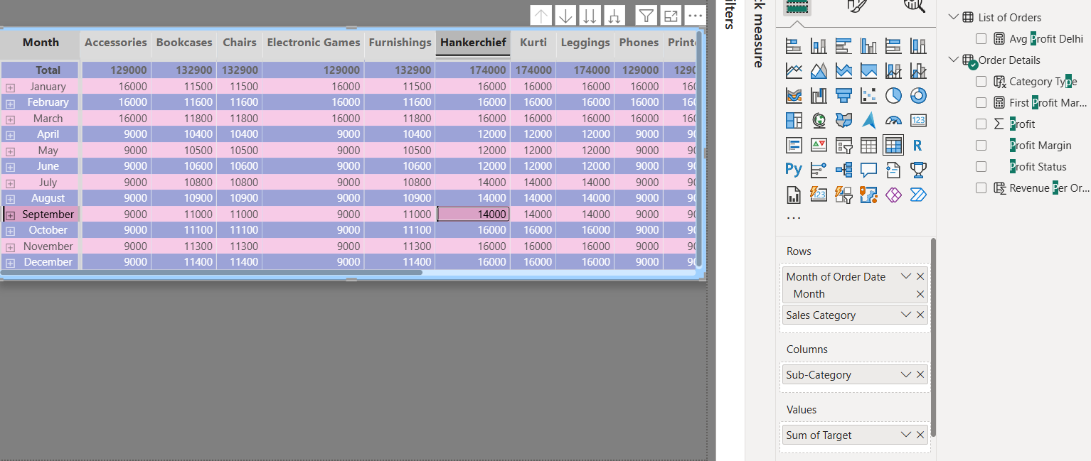

The above figure tells that actual sales compare to sales targets across different categories and months by using matrix view.

Geographic Sales Analysis

**Map**

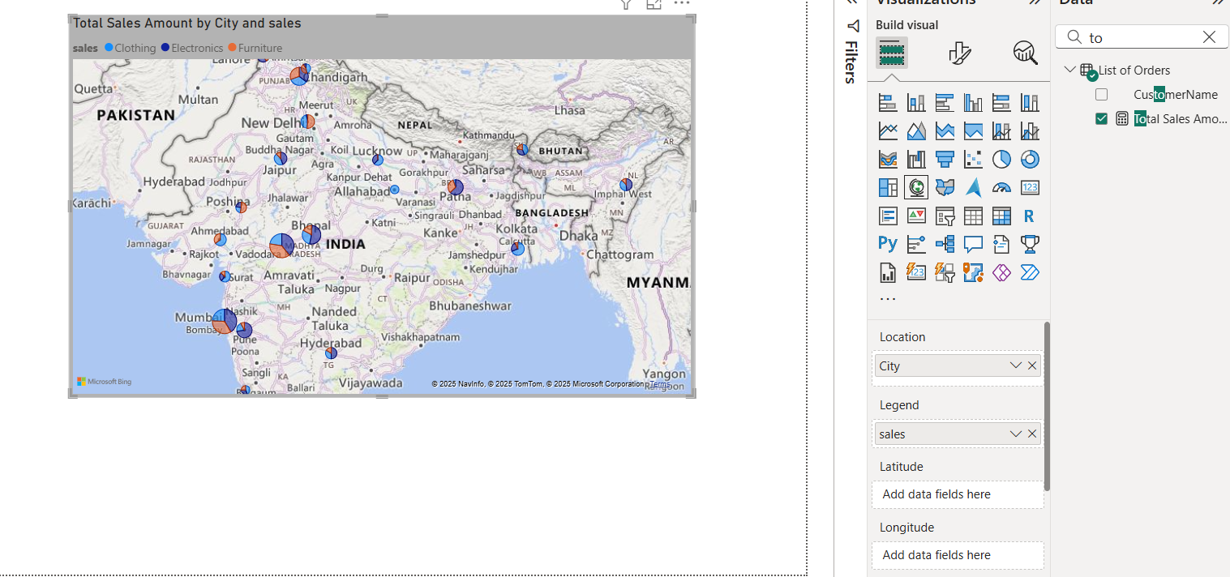

The above Map gives information about total sales across the city to identify regional sales patterns.

Sales Distribution by Sub-Category

**Tree map**

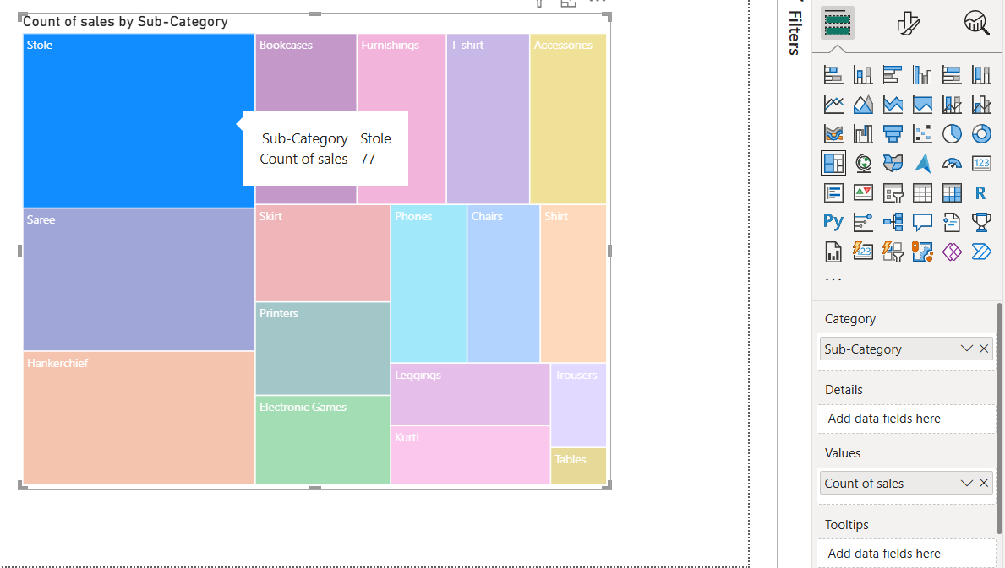

This figure treemap gives information about sales distribution across different sub-categories.

Order Count Analysis by State

**Funnel Chart**

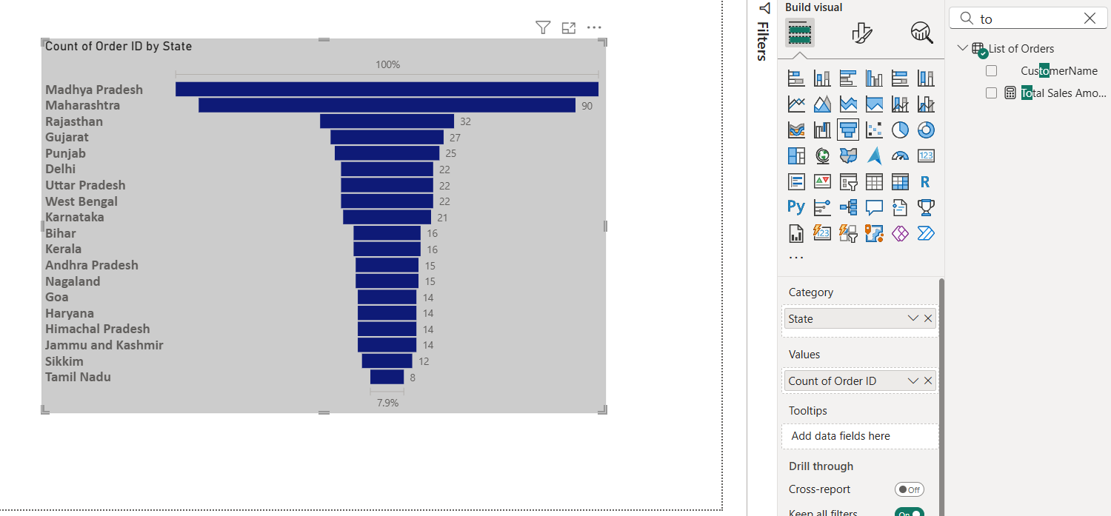

This Funnel chart tells the distribution of order counts across different states.

**Dashboard**

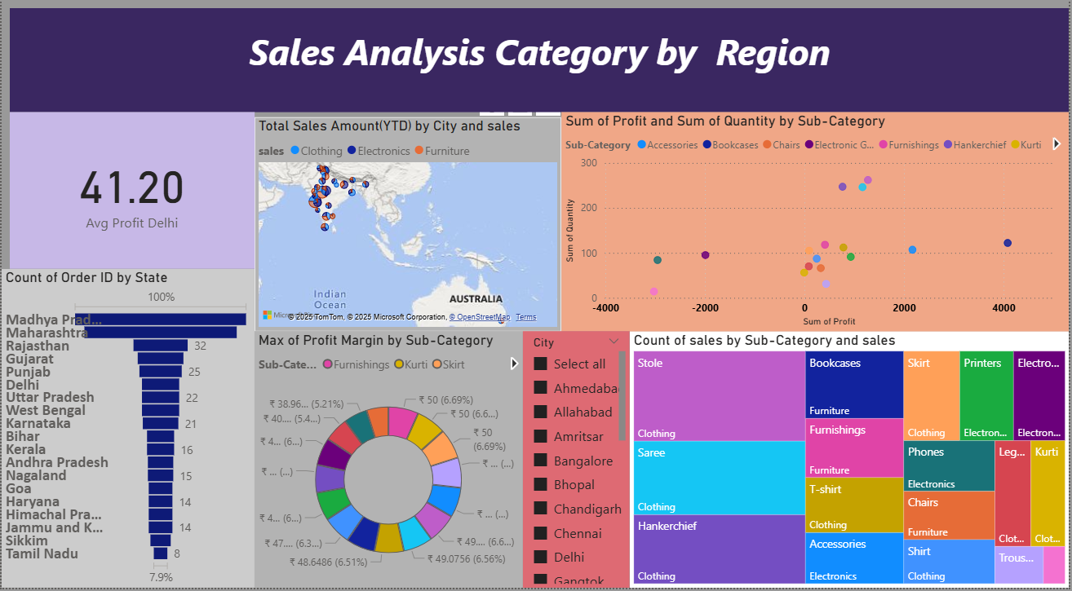

Dashboard gives information about five visualizing charts,

one card and one slicers.

Here slicers connect state wise to all charts.

Card is created for Average Profit Delhi value.

**Dashboard**

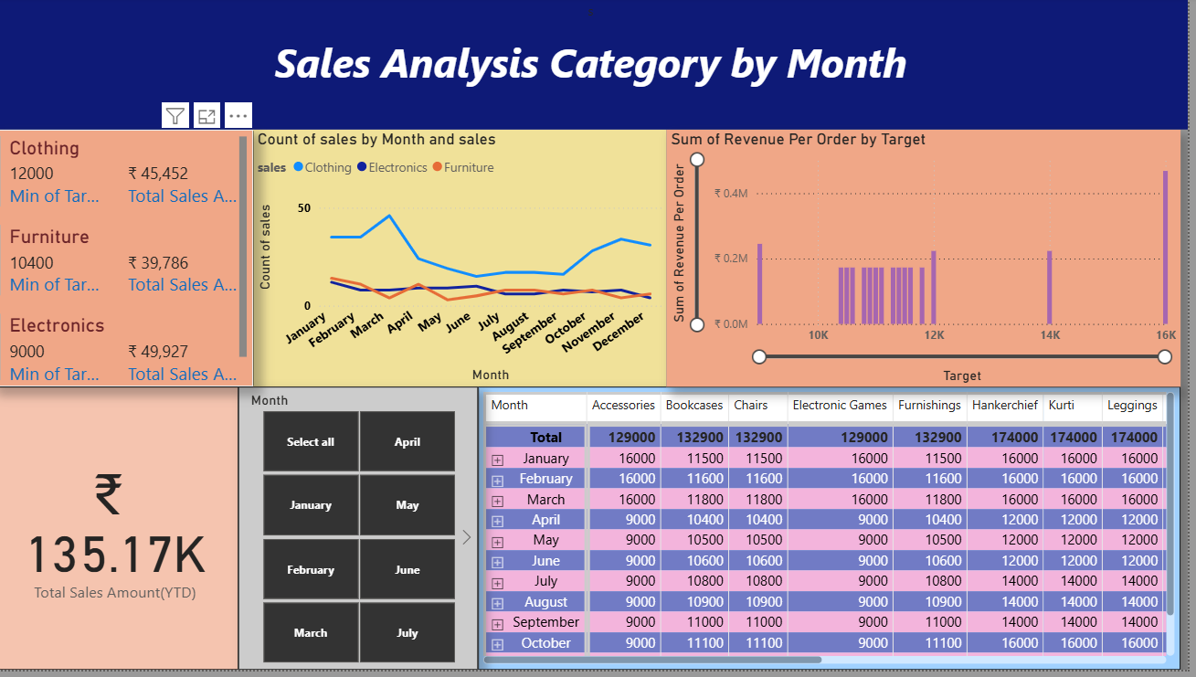

This dashboard gives information about three visualising charts, one silicer, one card and one multi row card.

Silicer created for monthwise comparison.

Card created for Total sales amount (YTD).

Multi row card created for minimum target values and total sales value.

Thank you sir